GEOPHYSICAL SURVEY CAMPAIGN FOR VEGONA II HYDROELECTRIC PROJECT
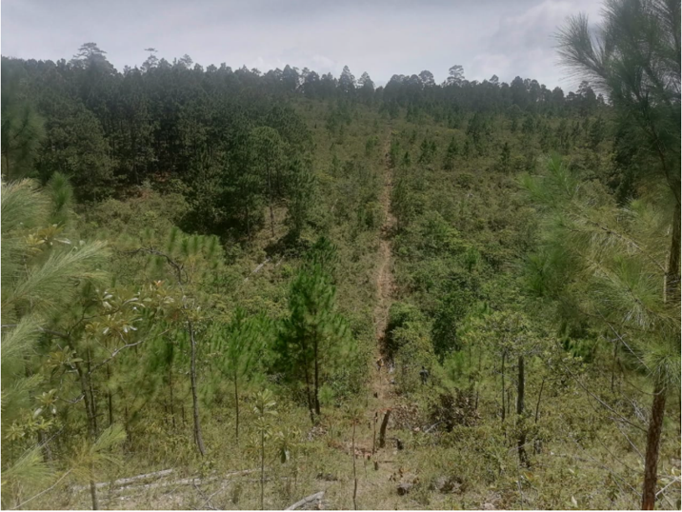
Location: Honduras
Client: Tunnel de Honduras SA
Methodology: Hybrid Seismic and Electric Tomography
Amount: 400.000 USD
Length: 27 km
Depth: 600 meters
Staff: 3 geophysicists plus 12 workers.
Geometry: spacing 5 meters
Duration: 3 months
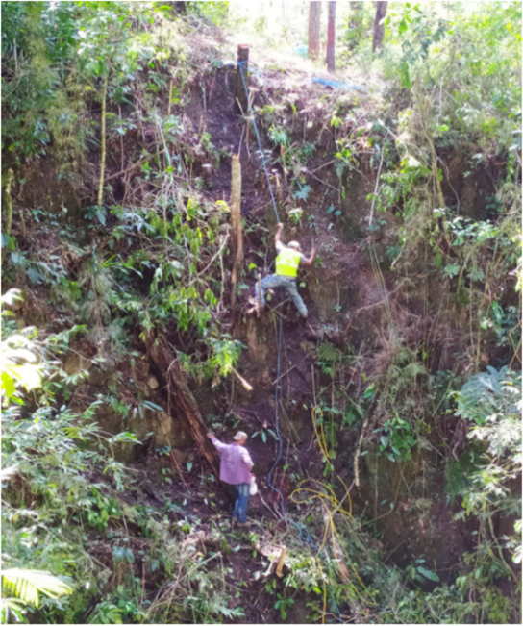
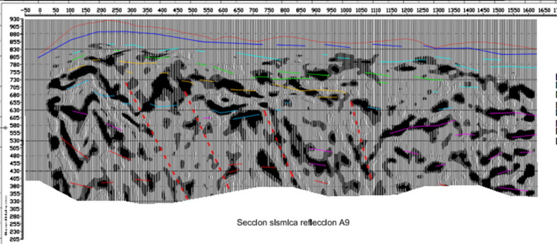
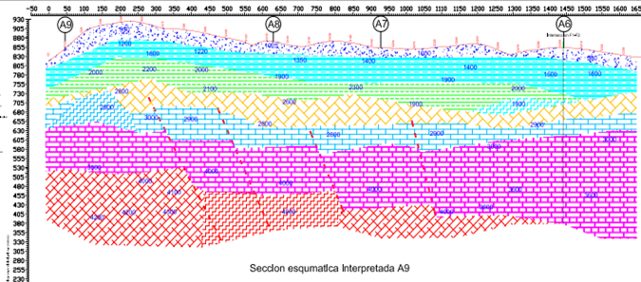
Project: Seismic reflection and refraction (hybrid seismic) investigations were carried out, integrated with electric tomographic surveys, in order to identify geology and tectonic structures. The area under study is located in the western region of Honduras where a project for the construction of a new hydroelectric dam is carried out. The aim of the surveys is to define the general stratigraphy and identify the main tectonic structures. The path of the water derivation tunnels, from the containment basins to the electricity production area, have suggested the use of reflection methods in order to reach depths of over 500 meters. For this reason, several longitudinal and transverse lines with lengths between 500 and 3500 meters have been executed. Where possible, the "walk away" method was used, with 96 active geophones 5 meters spacing. For seismic waves energization were used microcaric of gelatin 180 grams each. The explosions were located every 15 meters in order to achieve an average coverage of 3.200%. In correspondence of every section in reflection has been acquired also a section in refraction to the aim to interpret the data in "Hybrid" way The results of the data processing of seismic reflection and the evaluation of refractive tomography are based on the same data set, are completely independent of each other. This fact improves the reliability of a joint interpretation. In addition, the method is helped by a simultaneous processing of the two results, in which the disadvantages of one method are offset by the benefits of the other.

