SEISMIC INVESTIGATIONS AT THE PALO VIEJO HYDROELECTRIC PLANT

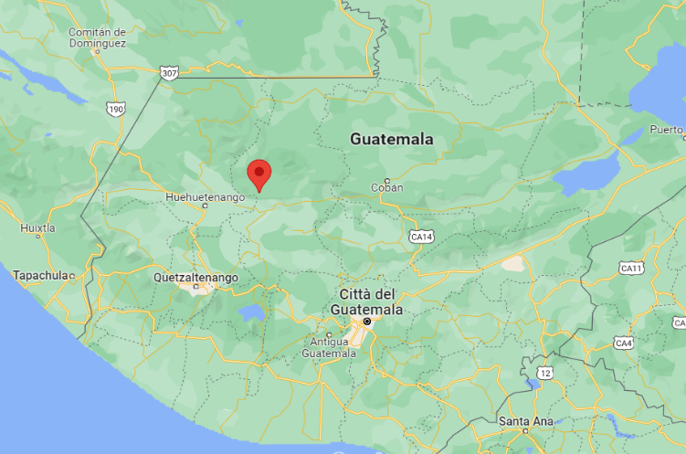
Client: Enel Green Power
Location: Guatemala
Amount: 200.000 USD
Metodology: Hybrid Seismic and Down Hole
Length: 16 km
Depth: 50 meters
Staff: 2 geophysicists plus 5 workers
Geometry: 5 meters spacing
Duration: 3 3 months
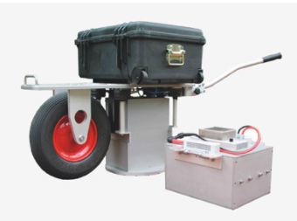
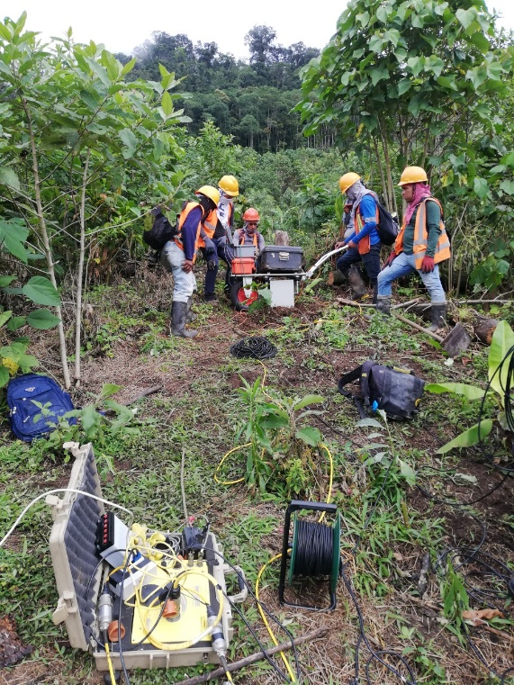
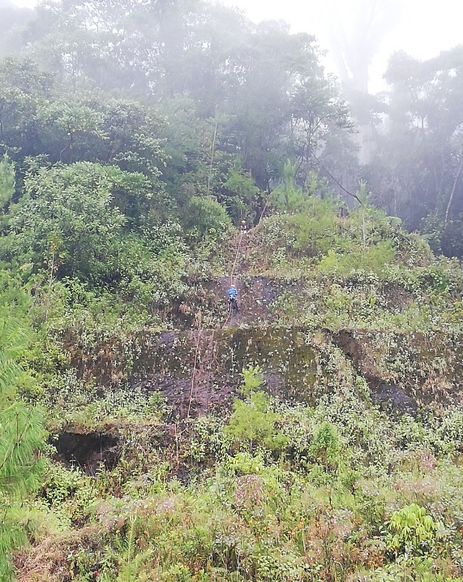
Project: The project is located in the central-western region of Guatemala, where there is a hydroelectric plant, owned by the Enel Green Power Group. The area is currently subject to phenomena of instability of the slopes insistent on the catchment basin. Reflection and refraction seismic survey (hybrid seismic), implemented with Down Hole investigations, were performed in order to identify the geology and tectonic structures of the landslide area. The investigations have, as their objective, the definition of detailed stratigraphy and the identification of the main structures which are the cause of even deep gravitational movemen. The need for underground information up to at least 200 meters deep suggested the use of reflection methodologies. In order to depth and detail need, were designed lines with 96 active geophones 2.5 meters spacing. To energize the seismic waves, an Elvis VII vibrating source was used to generate sweep signals P or S. The source consists of a moving mass driven by a linear cascade motor. An adjustable pneumatic suspension ensures maximum release of seismic energy. The energizations were located every 5 meters, in order to reach an average coverage of 4,800%. In correspondence of every section in reflection, it has been acquired also a section in refraction modality to the aim to interpret the data in "Hybrid" way. The results based on the same dataset, are completely independent each other by improving the reliability of a joint interpretation. The method is aided by a simultaneous processing of the two results, in which the disadvantages of one method are offset by the benefits of the other

