SUPPLEMENTARY SURVEY CAMPAIGN ST GOTTHARD PIPE PROJECT

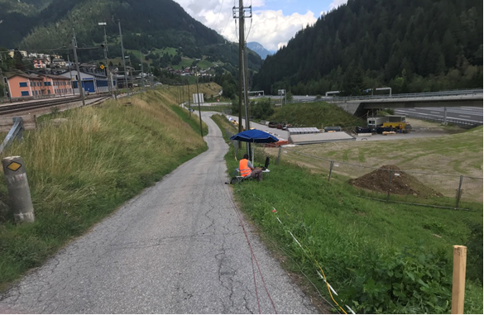
Client: Federal Office of Roads USTRA
Location: Airolo
Amount: 150.000 CHF
Metodology: Hybrid Seismic and Electric Tomography
Lenght: 10 km
Depht: 200 meters
Staff: 3 geophysicists plus 5 workers Geometry: 2.5 meters spacing
Duration: 3 months
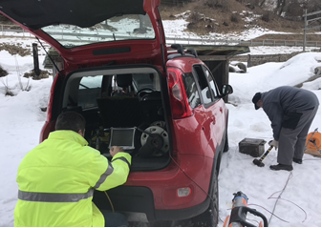
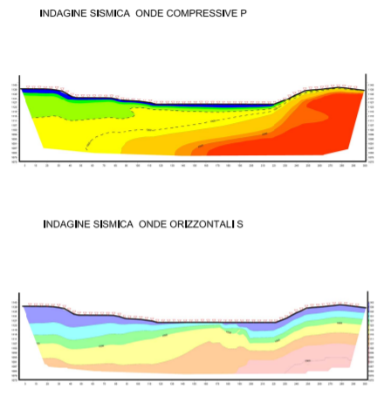
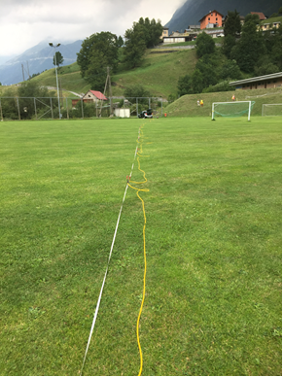
Project: During August and September 2019 and in January 2020, geophysical surveys were carried out in the area affected by the project related to the design of the second pipe of the Gotthard tunnel - National road N02 - second lot, in the territory of the Municipality of Airolo. The Client entrusted GEO ALPS CONSULTING SA with a survey aimed to defining the geophysical model of the subsoil. The planned geophysical surveys were carried out with the function of supporting the geological study and the on-site geotechnical tests. The objectives of the geophysical survey concern the reconstruction of the subsurface model both from the seismic and geoelectric point of view and the calculation of the main dynamic parameters. To supporting to the study of the geology affected by the path south of the exit of the second tunnel, 16 seismic lines were performed with surface refraction methodology, both in compressive and shear waves, with tomographic processing, 15 surface geoelectric lines with dipole-dipole geometry and dipole pole (combined) and tomographic processing, 6 Down Hole tests in borehole previously equipped with inclinometer. The tomographic elaboration has allowed to estimate the thickness of the covers and the depth of the probable rock substratum. Through the analysis of the propagation of the electrical signal in the ground, through a matrix of electrodes with known geometry, 2D sections of the resistivity of the different levels of soil, are returned, acquired both in the configuration of pole-dipole and dipole-dipole, showed substantial agreement with other investigations.

